

Stock Specification Sheet

Front near side image |  |  | Fleet Number | 12930  12931
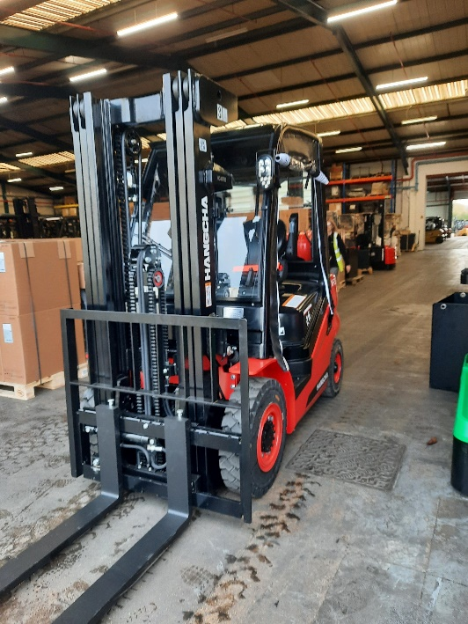

 |  |  | Year of Manufacture | 2024
 |  |  | Make | HANGCHA
 |  |  | Model | XF25L
 |  |  | Basic Capacity | 2500KG
 |  |  | Serial Number | 12930 = 13BD00381  12931 = 13BD00382
 |  |  | Power | GAS
 |  |  | Hours | NEW
 |  |  | Hyd. Lever Control Type | MC
 |  |  | Tyres | SOLID
Rear Off Side Image |  |  | Mast Type | TRIPLEX
 |  |  | Lift Height | 4700MM
 | 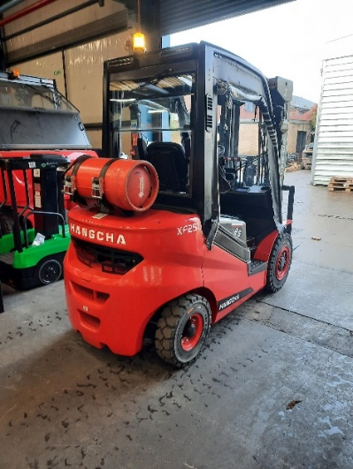
 |  |  | Closed Height | 2200MM
 |  |  | Free Lift Type | FULL FREE LIFT
 |  |  | Hosing to Carriage | 2
 |  |  | Fork Dimensions | 1150MM
 |  |  | Side Shift | INTEGRAL
 |  |  | Fork Positioner | N/A
 |  |  | Attachment 1 | REAR VIEW MIRROR
Seat and Cockpit Area |  |  | OHG Roof Cover | PERSPEX – TOP, FRONT AND REAR WITH WIPERS
 |  |  | Cabin | ROLL UP SIDES
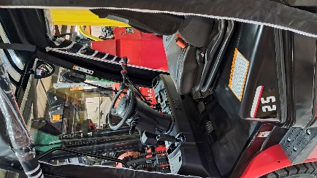
 |  |  | Flashing Beacon | YES REAR OHG
 |  |  | Safety Lights | SPOT LIGHTS
 |  |  | Battery | N/A
 |  |  | Battery Changing | N/A
 |  |  | Charger | N/A

